USER INTERFACE AND DESIGN
ROLL NO: 240701222 NAME: Kaaviya Sri PS
PRELIMINARY EXERCISE:
COMPARISON OF UI DESIGN BETWEEN TWO FIGMA INTERFACES

Two applications created for the purpose of food ordering and delivery have different interfaces, with specific designs and approaches. Upon comparing the two, one is superior to the other:

- Bad Design
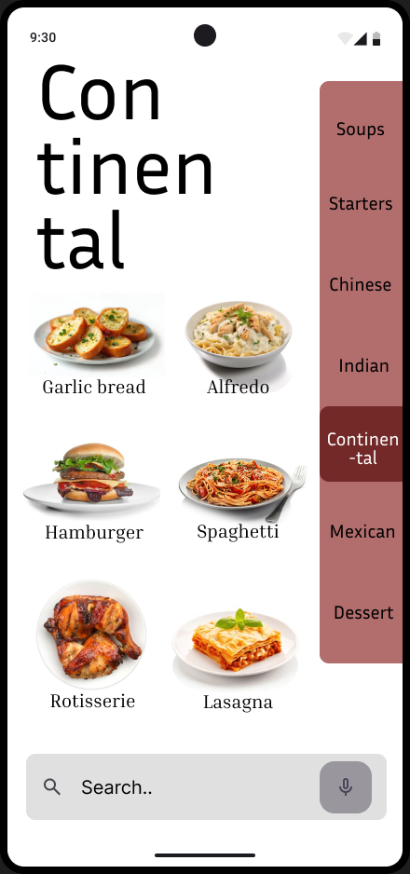
- Placement: The search bar doesn’t follow convention and is located at the bottom, becoming even more inconvenient due to misclicks and requirement for recall.
- Navigation: The sidebar menu is placed on the right, which makes it inconvenient for right handed users (the majority) since misclicks, gestures and accidental skin brushing from the right hand can unwantedly change categories.
- Design Style: The minimalist, modern design is not appropriate nor attractive for a food delivery app, making it look bland and boring.
- Clarity: The font chosen has uneven spacing, cutting the words in half and reducing readability.
- Iconography: The food icons have white backgrounds, reducing visibility of each icon’s clear borders. This can result in accidental clicks and adding of food items when scrolling or navigating the page.

- Good Design
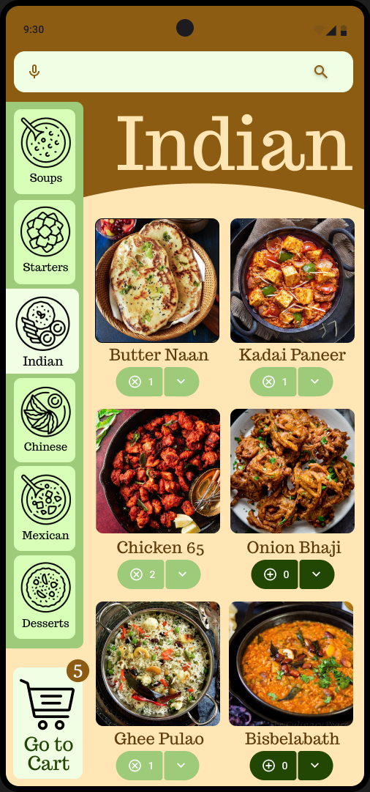
- Placement: The search bar has been placed per convention in the top of the layout, easily recognisable by users.
- Navigation: The sidebar opens from the right, allowing users to change categories while not interfering with item selection and navigation.
- Design Style: A vibrant, warm toned palette with lively styling has been applied, making the design more appealing and appropriate for a food ordering application.
- Clarity: The font is readable and clear, yet stylised to fit the theme.
- Iconography: The icons are evenly spaced and contrasting the backdrop, and selection of items changes their color, making the UI responsive to the user’s actions; a user can easily understand what they’ve ordered and the quantity of each.

Key Differences:
- Aesthetics: Selecting the appropriate style for the application’s use to make the UI more fitting.
- Organisation: Placement of the page components keeping in mind the user’s experience.
- Recognition: Prioritising user’s pattern recognition over innovating unnecessarily and confusing users.

DESIGN LINK: https://www.figma.com/design/EHgny5Y97ozO7KsrybNU1v/Good-v-Bad?node-id=0-1&t=Pz0ZoM9DPnmMobZn-1

